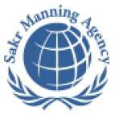 | SAKR MANNING AGENCY  FOR RECRUITING EGYPTIAN LABOR ABROAD | Issue Date | 15.05.2022
 | SAKR MANNING AGENCY  FOR RECRUITING EGYPTIAN LABOR ABROAD | Revision Date | 27.05.2023
 | Crewing Management Manual  Seafarer Employment Application | Revision | 1.2
 | Crewing Management Manual  Seafarer Employment Application | Page | 3
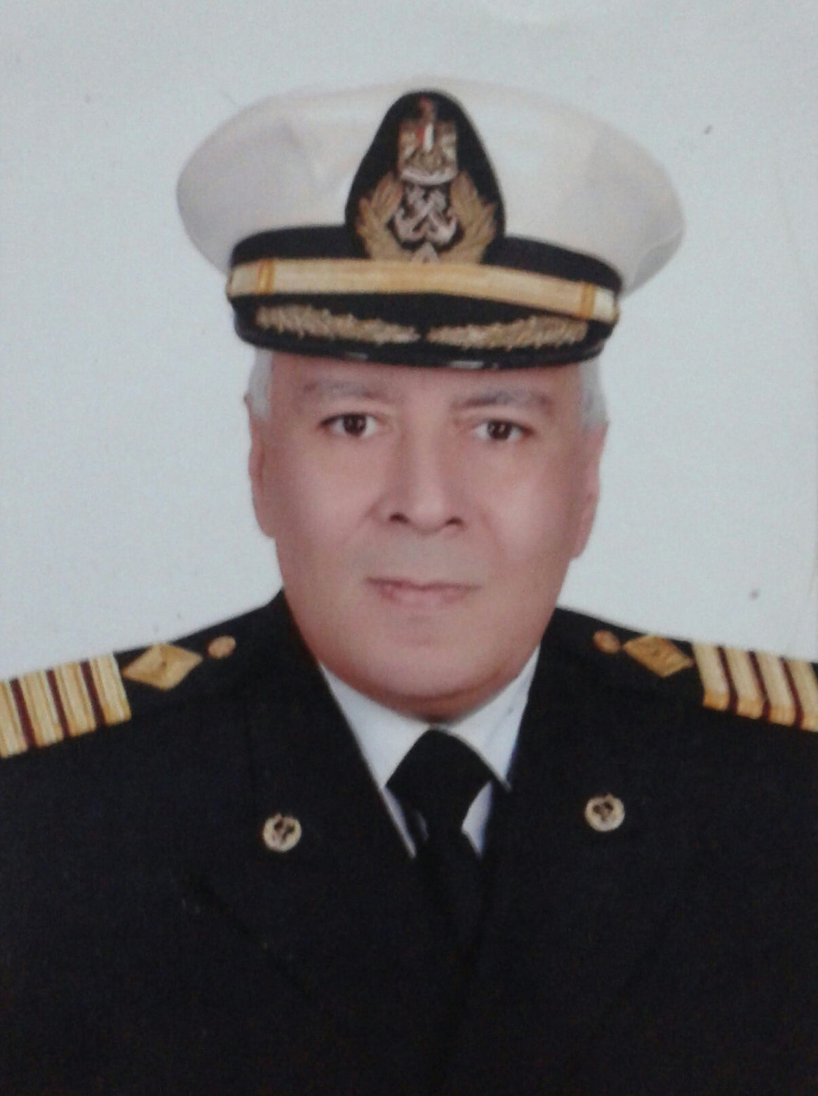
Application For Position as | Marine Chief Engineer
Register Code. | EO-1.039
Other Position (If Any)
Register Date | 6/9/2023
Last up Date Data
Expected Salary | $350/day

1. PERSONAL DETAILS
Full Name |  | Mohamed Kamal-Eldin Mohamed Nagib Tharwat
Date Of Birth |  | 28-1-1962 |  |  |  |  |  |  | Place Of Birth |  |  |  |  |  |  |  | Alexandria, Egypt
Nationality |  | Egyptian |  |  |  |  |  |  | Marital Status |  |  |  |  |  |  |  | Single |  |  |  |  |  |  |  | Married
Height (Cm) |  | 174 |  |  |  |  |  |  | Overall Size |  |  |  |  |  |  |  | XXL |  |  |  |  | Shirt Size |  |  |  |  |  | XXL
Weight (Kg) |  | 95 |  |  |  |  |  |  | Trouser Size |  |  |  |  |  |  |  | XXL |  |  |  |  | Shoes Size |  |  |  |  |  | 43
2. EDUCATION
College / School |  | Faculty of Engineering, Alexandria University
Marline Test |  | Issued Date |  |  |  |  | Result % |  |  |  | Issued By (Authority) |  |  |  |  |  |  |  |  |  | Issued At
 |  | - |  |  |  |  | - |  |  |  | - |  |  |  |  |  |  |  |  |  | -
English Language |  | Fluent |  |  |  |  |  | Good |  |  |  |  | Average |  |  |  |  |  |  |  | Poor
……… Language  ( ) |  | Fluent |  |  |  |  |  | Good |  |  |  |  | Average |  |  |  |  |  |  |  | Poor
3. CONTACT DETAILS
Home Address / City |  |  | Building no. 58, El-Sayed Radwan St. branched from Iskander Ibrahim St, Miami, Alexandria, Egypt.
E-Mail |  |  | mohamedkamaltharwat@gmail.com |  |  |  |  |  |  | Mobile / Tel |  |  |  |  |  | +201061286858 |  |  |  |  |  |  | +2035503459

4. TRAVEL DOCUMENTS
Type |  | Document No. |  |  |  | ISS. Date |  |  | Exp. Date |  |  |  |  | ISS. By (Authority) |  |  |  |  |  |  |  |  |  | Place of Issue
Passport |  | A30444385 |  |  |  | 12/05/2022 |  |  | 11/05/2029 |  |  |  |  | Egyptian Authority |  |  |  |  |  |  |  |  |  | 18
Seaman Book |  | S00021299 |  |  |  | 06/03/2022 |  |  | 18/11/2026 |  |  |  |  | EAMS |  |  |  |  |  |  |  |  |  | Alex.
Other Seaman Book |  | 1095749 |  |  |  | 14-09-2016 |  |  | 31-12-2016 |  |  |  |  | REPUBLICA DE PANAMA |  |  |  |  |  |  |  |  |  | Panama

5. PROFESSIONAL QUALIFICATION / CERTIFICATE OF COMPETENCY
Certificate Name |  |  |  |  | Number | Issue Date |  |  |  |  |  | Expiry Date |  |  |  |  |  | Issued By |  |  |  |  |  |  |  |  | Issued At
COC ( Rank) ………….. |  |  |  |  | 1745 | 23-02-2022 |  |  |  |  |  | 18-11-2026 |  |  |  |  |  | EAMS |  |  |  |  |  |  |  |  | Alex.
GOC |  |  |  |  |  |  |  |  |  |  |  |  |  |  |  |  |  | NTRA |  |  |  |  |  |  |  |  | Cairo
D.P. INDUCTION |  |  |  |  | - | - |  |  |  |  |  | - |  |  |  |  |  | - |  |  |  |  |  |  |  |  | -
D.P. ADVANCED |  |  |  |  | - | - |  |  |  |  |  | - |  |  |  |  |  | - |  |  |  |  |  |  |  |  | -
D.P. OPERATOR (UNLIMITED) |  |  |  |  | - | - |  |  |  |  |  | - |  |  |  |  |  | - |  |  |  |  |  |  |  |  | -
6. NEXT OF KIN
Full Name | Kamal Mohamed Kamal-Eldin Tharwat |  |  |  |  |  |  |  |  |  |  |  |  |  | Relationship |  |  |  |  | Son
Address | Building no. 58, El-Sayed Radwan St. branched from Iskander Ibrahim St, Miami, Alexandria, Egypt.
Tel. No. | +2035503459 |  |  |  |  |  |  |  |  | Mobile |  |  | +201210621617
7. HEALTH CERTIFICATES & VACCINATIONS
Flag State |  |  |  | Number |  |  | Issue Date |  |  |  |  | Expiry Date |  |  |  |  |  |  | Issued By |  |  |  |  |  |  | Issued At
International Medical |  |  |  | 1745 |  |  | 27/03/2022 |  |  |  |  | 26/03/2024 |  |  |  |  |  |  | EAMS |  |  |  |  |  |  | Alex.
Yellow Fever |  |  |  | 1014 |  |  | 07/06/2023 |  |  |  |  | Forever |  |  |  |  |  |  | Ministry of Health |  |  |  |  |  |  | Alex.
Cholera |  |  |  | - |  |  | - |  |  |  |  | - |  |  |  |  |  |  | Ministry of Health |  |  |  |  |  |  | -
Covid-19 |  |  |  | Vaccination Name |  |  | First Dose |  |  |  |  | Second Dose |  |  |  |  |  |  | (Other Does or Remarks)
 |  |  |  | Sputnik V |  |  | 26-01-2022 |  |  |  |  | 16-02-2022

8. MARINE COURSES
Course Name | Number | Issue Date | Expiry Date | Issued By / At
Personal Survival Techniques
Proficiency In Personal Survival Techniques | 42315/21/EG | 7/12/2021 | 6/12/2026 | AAST
Fire Prevention and Fire Fighting
Advanced Fire Prevention and Fire Fighting | 39879/21/EG | 18/11/2021 | 17/11/2026 | AAST
Elementary First Aid | 43483/21/EG | 16/12/2021 | 15/12/2026 | AAST
Medical Care Studies
Personal Safety and Social Responsibilities | 42585/21/EG | 9/12/2021 | 8/12/2026 | AAST
Proficiency Of Security Awareness Training Seafarers | 10599/23/EG | 29/3/2023 | 26/3/2028 | AAST
Proficiency as a ship Security officer ( PSSO )
Proficiency In Survival Craft & Rescue Boats | 42683/21/EG | 9/12/2021 | 8/12/2026 | AAST
G.M.D.S.S
Communications
Advanced Communications
ECDIS Advanced Simulator (Management Level)
ECDIS Simulator (Operation Level)
Prevention and Combating of Marine Pollution | 46871/16/EG | 20/10/2016 | XXXXXXXX | AAST
Radar & ARPA Simulator and Search &rescue
ARPA Simulator and Search
Marine Radar and automatic Radar Plotting
Bridge resource Management (B.R.M)
Engine resource Management (E.R.M)
Navigational Watch keeping
Proficiency for Rating forming part of Navigational watch (II/4) |  |  |  | EAMS / Alex.
High voltage training – operation of ship (1000 Volt and More)
Passenger Safety Cargo Safety and Hull integrity
Crowd Management Training
Crisis Management and Human Behavior Training
Safety training for Personal Prov. Direct Passengers
Practical Ability to Prepare Meals and (MLC 2006)
Personal Hygiene and Envir. Protection (MLC 2006)
Safety and Health in the Provision Meals (MLC 2006)
Food Storage and inventory Control (MLC 2006)
Ships Cook Certificate (MLC 2006) |  |  |  | EAMS / Alex.
Abel Seafarer Deck
Proficiency for Abel Seafarer Deck ( II/5 ) |  |  |  | EAMS / Alex.
Engineering Watch keeping |  |  |  | EAMS / Alex.
Proficiency for Rating forming part of a watch in engine room
Abel Seafarer Engine
Proficiency for Abel Seafarer Engine ( III/5 ) |  |  |  | EAMS / Alex.
Electro Technical Rating
Proficiency for Electro Technical rating ( III/7 ) |  |  |  | EAMS / Alex.

 |  |  | COMPLETE SEA – SERVICE DETAILS
Name: | Mohamed Kamal-Eldin Mohamed Nagib Tharwat |  |  |  |  |  |  |  |  |  |  |  |  |  |  | Rank: | Marine Chief Engineer |  |  |  |  |  | Register Code:
Company Name |  |  |  |  |  | Rank | Vessel Name |  |  | Flag |  | Signed On |  |  |  |  |  | Signed Off |  |  | Period |  |  | Vessel Type |  |  |  | D.W.T. |  |  | Engine Type |  | BH |  |  |  | KW
SG MARINE AND OIL SERVICES |  |  |  |  |  | Chief Engineer | SG 9 - SG 11 |  |  | Egyptian |  | 24/10/2022 |  |  |  |  |  | - |  |  | 10 months so far |  |  | Tug Supply Vessel |  |  |  | Supply Vessel |  |  | MAN |  | 3000 |  |  |  | 2000
Subsea Petroleum Services co. |  |  |  |  |  | Chief Engineer | Sukhna 2 |  |  | Egyptian |  | 1/1/2018 |  |  |  |  |  | 2/5/2018 |  |  | 4 months |  |  | AHTS |  |  |  | Supply Vessel |  |  | Daihatsu |  | 6000 |  |  |  | 4000
ELTimsah for shipbuilding Co. |  |  |  |  |  | Chief Engineer | Tim sumed - Tim barge - Tims 1 |  |  | Egyptian |  | 1/4/2017 |  |  |  |  |  | 31/8/2017 |  |  | 5 months |  |  | AHTS -  Workshop Barge |  |  |  | Supply Vessel – Heavy Lift Barge 124 ton |  |  | MaK |  | 6000 |  |  |  | 4000
I.N.W. COMPANY |  |  |  |  |  | Chief Engineer | I.N.W.1 |  |  | Panama |  | 14/7/2016 |  |  |  |  |  | 11/10/2016 |  |  | 3 months |  |  | Supply Vessel |  |  |  | Supply Vessel |  |  | G.M |  | 3000 |  |  |  | 2000
BERG  OFFSHORE EGYPT |  |  |  |  |  | Chief Engineer | DRIVE MAHONE |  |  | Norway |  | 13/5/2015 |  |  |  |  |  | 23/5/2015 |  |  | 10 days |  |  | AHTS |  |  |  | Supply Vessel |  |  | MaK |  | 10800 |  |  |  | 7200
BMC LINES SHIPPING CO. |  |  |  |  |  | BMC Master | Container Ship |  |  | Egyptian
 |  | SPECIALISED EXPERIENCE
 |  | Name |  |  |  |  |  |  |  |  |  |  |  |  | Type |  |  |  |  | From |  |  |  |  | To |  |  |  | Comments
 |  | I declare that the information I have given is, to the best of my knowledge, true and complete. I also declare that the documents submitted are genuine, given and sign by persons whose names appear on them.
 |  |  |  |  |  |  |  |  |  |  |  |  |  |  |  |  |  |  |  |  |  | DATE |  |  |  |  |  |  |  |  | SIGNATURE

